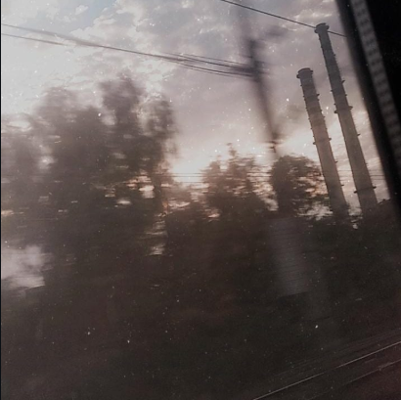

"I don't know anymore" I say,
As if I knew anything to begin with,
An identity, they're trying to give me,
A flawed design, I don't wanna fit in

I read somewhere, that we're just a culmination of all those we meet,
So If they do judge, are they judging themselves,
Or it is really me?

High on my vibe,
Drunk on my feels,
This toxicity flowing in my veins,
I wonder , what's wrong with us,as a specie,
Why give me a conscience to suffer from,
Why, you sadistic genes?

A battle for an acquired Identity,
A battle for validation,
A battle to just feel,

The way I used to,
When I knew, what it meant to "be"

